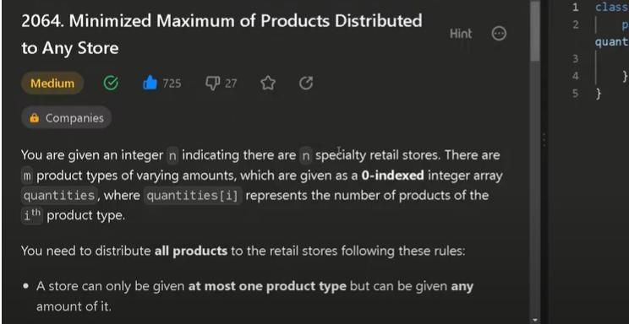
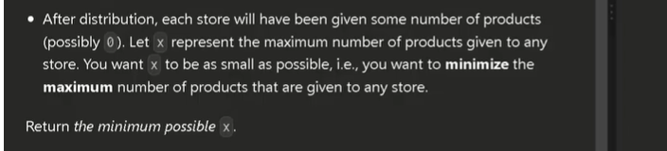
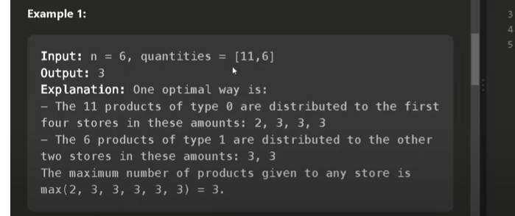

🔸 Problem:
Distribute the quantities {11, 15, 9, 7} among n = 6 stores in such a way that the maximum number of products any store gets is minimized.

🔸 Goal:
Find the minimum possible value of the maximum number of products per store (i.e., minimize the "maximum load").

🔸 Step 1: Binary Search Range
From code:
- start = 1
- end = max(quantities) = 15
So we’ll do binary search from 1 to 15.

🔸 Step 2: Binary Search Loop
Let’s track each iteration:
